**Direct Sun Equation**

The direct sun equation is the key to getting ozone values from the Dobson, regardless of whether the observation is a zenith or a direct sun (more on both in later chapters). This is because the zenith observations are matched up to the direct sun measurements and an equation for zenith is derived from intercomparison of these two data sets.

When doing ozone measurements, we use three main sets of short and long wavelength pairs, referred to as A, C and D. The short wavelength in each of these pairs is highly absorbed by ozone and the long wavelength is relatively unaffected by ozone. The principle that the Dobson operates on is by looking at the ratio of the wavelengths in each pair, we can find out the amount of ozone in the atmosphere.

Without further ado, let’s look at the equation [1], the derivation of which can be found in the appendix.

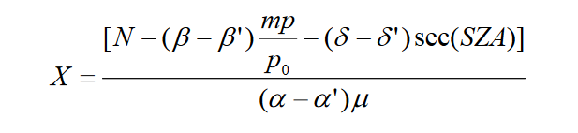

Where X = ozone amount in Dobson units

N = L0 – L = log(I0/I’0) – log(I/I’)

Where I0 and I’0 intensities outside the atmosphere of solar radiation at the short and long wavelengths, respectively, of the wavelength pair;

I and I' = measured intensities at the ground of solar radiation at the short and long wavelengths, respectively

α and α' = absorption coefficients of ozone at the short and long wavelengths, respectively. The value of α is given by Bass and Paur [2]

β and β’ = Rayleigh scattering coefficients of air at the short and long wavelengths, respectively. The value of β is again given by Bass and Paur [2]

δ and δ' = scattering coefficients of aerosol particles at the short and long wavelengths, respectively.

μ = ratio of the actual and vertical paths of solar radiation through the ozone layer. [1]

m = ratio of the actual and vertical paths of solar radiation through the atmosphere, taking into account refraction and the earth's curvature, also known as air mass [3]

p and p0 = observed station pressure and mean sea level pressure

SZA = solar zenith angle - angular zenith distance of the sun; with 0 as sun directly overhead, 90 as at the horizon.

The above equation comes from only using one wavelength pair to calculate ozone. However, we mostly use two pairs of short and long wavelengths, for example the “A” pair and the “D” pair. Doing this means we can get rid of the delta terms and their SZA angle dependence, as both pairs are equally affected by aerosol scattering and this effect cancels out. The unsimplified equation for two wavelengths reads as follows [1]:

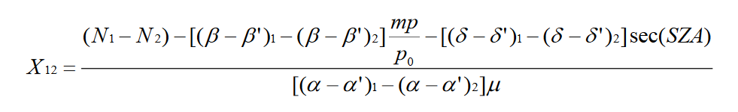

Where the 1’s and 2’s refer to each of our wavelength pairs (e.g. 1 refers to A and 2 to D). But we assume that (δ – δ’)1 ~= (δ – δ’)2 ; the elimination of the aerosol term “δ” means that this two-wavelength approach is particularly useful for polluted environments. We also assume that our m~= μ (which is true up to zenith angles of up to ~80 degrees). This now gives us the simplified equation for direct suns:

$$X_{12}=\frac{\left(N_{1}-N_{2}\right)}{[{\left(α-α^{'}\right)}_{1}-{\left(α-α^{'}\right)}_{2}]μ}-\frac{\left[{\left(β- β^{'}\right)}_{1}-{\left(β- β\right)}_{2}\right]\frac{p}{p_{0}}}{{\left(α-α^{'}\right)}_{1}-{\left(α-α^{'}\right)}_{2}}$$

We will go over in detail how to obtain the N-values from the R-dial in a later section. For now, let’s look at the rest of the terms of this equation and where to find them, starting with the most complicated: µ.

As described above, mu is the ratio of the actual path and the vertical (or shortest) path through the ozone layer [1]:

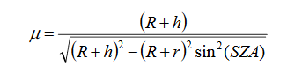

Where R is the radius of the Earth; h is the height of the ozone layer; r is the height of the station above sea level and SZA is the solar zenith angle. If no measurement of the height of the ozone layer exists, from ozonesondes for example, then the height of the ozone layer can be approximated from the following table [1]:

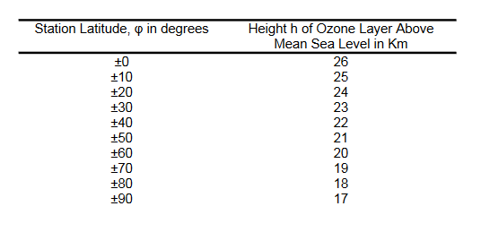

Figure 1 Table showing approximations for the height of the ozone layer with latitude.

This approximation comes from treating the mass of the atmosphere above any given location as being constant across the globe. Given this assumption, the depth of the atmosphere can be seen solely as a function of temperature, which in turn is (roughly) a function of latitude. Antarctica however has a strong polar vortex in winter, during which temperatures can fall very rapidly. This is followed by a breakdown of the vortex in spring/summer, which gives it a large change in temperature, compared to the equivalent latitude in the north – the Arctic. Corresponding to this is a change in the height of the ozone layer, as can be seen from this graph that is derived from ozonesondes at Neumayer station: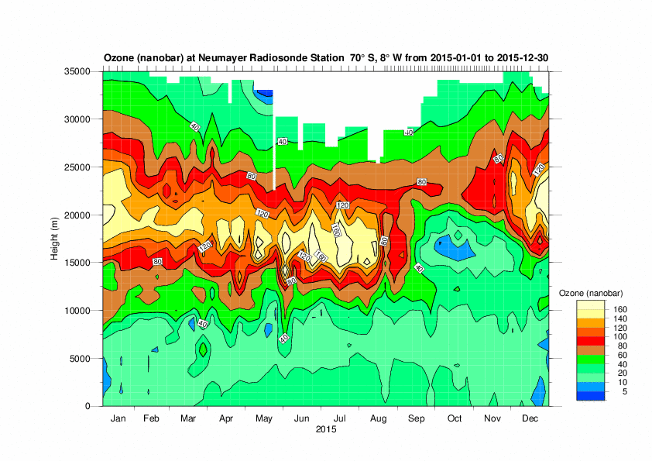

Figure 2 Graph showing the change in the height of the ozone layer at Neumayer in 2015. Note how the height of the ozone layer changes from ~21km in late December, to ~16km in midwinter. [2]

Because the height of the ozone layer changes throughout the year, our calculation of mu should ideally change with it. It may be possible to use Dobson data to derive the profile of the ozone layer, however this has not yet been tried at BAS*.

The surface pressure p and mean sea level pressure p0 can be found in the meteorological data from a station, perhaps most easily in the SYNOP observations, where the 3 group contains the sea level pressure and the 4 group contains the surface pressure. It should be noted that for Halley, which is at 20-30m above sea level, p and p0 are generally taken to be equal.

The remaining terms of our equation are constants. Those currently used by BAS are the “Bass-Paur” constants [2] and can be found in the data file for a specific Dobson:

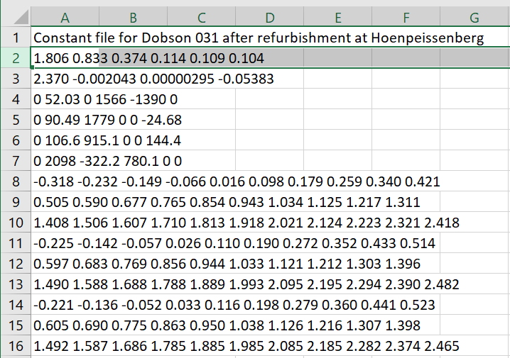

*Figure 3 From the file “D031E.DAT” in Z:\cmet\OZONE\dobsons, where Z is mapped to* *\\samba.nerc-bas.ac.uk\cmet* *. The file naming convention is D (Dobson) ###(serial number) _(letter of the alphabet) the letter increases with each calibration, e.g. after the next calibration of this Dobson, the filename will be D031F.DAT.*

The constants in line 2 are in order: 1.806 = A-alpha (α – α’), 0.833 = C-alpha, 0.374 = D-alpha, 0.114 = A-beta, 0.109 = C-beta, 0.104 = D-beta. Where each pair of wavelengths (A, C and D) have their own respective alpha and beta constants.

With all this, we should now have almost all we need to find ozone amounts from our measurements. “Almost” because we still need to tackle N values, this will be the next section.

*We currently use a constant for the height of the ozone layer. Using a monthly average of ozone layer height for a station in our calculation of mu or trying to calculate the height of the ozone layer from umkehr (more on these later) observations could be a useful way to improve the accuracy our ozone data.

References:

[1] GAW Report, 183. Operations Handbook - Ozone Observations with a Dobson Spectrophotometer: revised 2008. [*https://library.wmo.int/index.php?lvl=notice_display&id=12630*](https://library.wmo.int/index.php?lvl=notice_display&id=12630)

[2] Bass A.M., Paur R.J. (1985) The Ultraviolet Cross-Sections of Ozone: I. The Measurements. In: Zerefos C.S., Ghazi A. (eds) Atmospheric Ozone. Springer, Dordrecht. [*https://doi.org/10.1007/978-94-009-5313-0_120*](https://doi.org/10.1007/978-94-009-5313-0_120)

[3] *https://en.wikipedia.org/wiki/Air_mass_(astronomy)#Nonrefracting_spherical_atmosphere*

[4] [*https://www.awi.de/en/science/long-term-observations/atmosphere/antarctic-neumayer/meteorology/ozone.html*](https://www.awi.de/en/science/long-term-observations/atmosphere/antarctic-neumayer/meteorology/ozone.html)

Appendix: Derivation of the Direct Sun Equation

This section owes largely to the early work of GMB Dobson, who gave his name to the instrument, I recommend reading the Annals of the International Geophysical Year to see that derivation [A1].

Any beam of light at a specific wavelength at the top of the atmosphere will be attenuated by the time it reaches us by two processes: scattering and absorption. The Beer-Lambert Law can be expressed as [A2]:

$$I=I_{0}e^{-az}$$

Where I and I0­ are the intensities of light at the top and bottom of the atmosphere, a is the “attenuation coefficient” and z is the length of path travelled. If we are considering somewhere at sea-level, we can multiply the attenuation coefficient by the depth of our atmosphere, effectively using units where z = 1 atmosphere. We can then split this value “a” up into our absorption and scattering coefficients, α (ozone absorption), β (Rayleigh Scattering) and δ (aerosol scattering) and then multiply α by the ozone concentration:

$$I=I_{0}e^{-(αx+β+ δ)}$$

This equation is valid for when the sun is directly overhead, i.e. zenith angle = 0, as this is when a beam of light traverses the thickness of our atmosphere. However, for other zenith angles, more atmosphere is traversed and therefore there will be greater extinction of light. Thus, we need to include a factor in each term that tells us what our path length is relative to 1 atmosphere. This is what “airmass” m is, the relative path length through the atmosphere, where a zenith angle of zero makes m = 1. The factor μ is also similar to this, however, μ is set relative to the thickness of 1 ozone layer, as this is where our ozone is concentrated, rather than throughout the entire atmosphere. Furthermore, this is where our factor “sec(Z)” comes from in the aerosol scattering term, however, I have been unable to find a reference for where exactly this comes from, apart from the idea that a good approximation for m is sec(Z) [A3]. This now gives us:

$$I=I_{0}e^{-(αxμ+βm+δ\sec\left(Z\right))}$$

Taking the logarithm of both sides converts to:

$$\log{\frac{I}{I_{0}}}=-(αxμ+βm+ δ\sec\left(Z\right))$$

Now of course, in our Dobson we measure two wavelengths of UV light, one greatly absorbed by ozone, the other, weakly or not at all. If we take the absorption and scattering constants for both wavelengths, we get: $$\log{\frac{I}{I_{0}}}-\log{\frac{I^{'}}{{I^{'}}_{0}}} =-(\left(α-α^{'}\right)xμ+\left(β-β^{'}\right)m+\left(δ-δ^{'}\right)\sec\left(Z\right))$$

$$-\log{\frac{I{I^{'}}_{0}}{I_{0}I^{'}}} =\left(α-α^{'}\right)xμ+\left(β-β^{'}\right)m+\left(δ-δ^{'}\right)\sec\left(Z\right)$$

$$\log{\frac{I_{0}}{{I^{'}}_{0}}}-\log{\frac{I}{I'}}-\left(β-β^{'}\right)m-(δ-δ') sec⁡(Z)=\left(α-α^{'}\right)xμ$$

$$\frac{\log{\frac{I_{0}}{{I^{'}}_{0}}}-\log{\frac{I}{I'}}-\left(β-β^{'}\right)m-(δ-δ') sec⁡(Z)}{\left(α-α^{'}\right)μ}=x$$

Where = L0 – L = N. Finally we can apply a pressure correction term to m of p/p0 for stations that are not at sea level, giving us:

$$x= \frac{N-\left(β-β^{'}\right)m\frac{p}{p_{0}}-(δ-δ') sec⁡(Z)}{\left(α-α^{'}\right)μ}$$

[A1] Dobson, (1957) Annals of the International Geophysical Year

[A2] <https://en.wikipedia.org/wiki/Mass_attenuation_coefficient>

[A3] <https://en.wikipedia.org/wiki/Air_mass_(astronomy)#Plane-parallel_atmosphere>